Dethick, Lea and Holloway

**Horticultural Society**

**Annual Programme 2025**

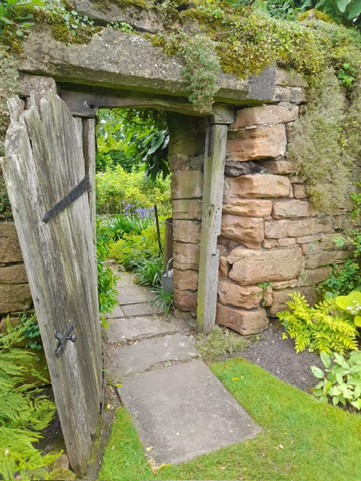

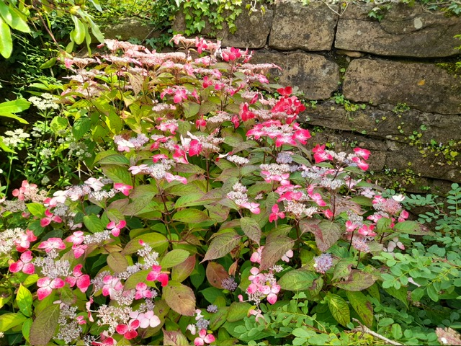

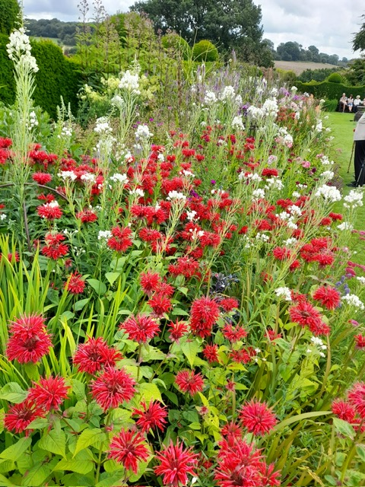

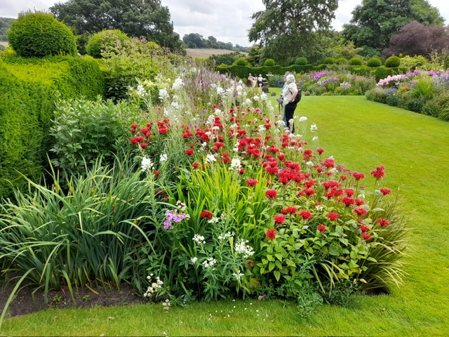

|  |  |
| --- | --- |
| **Fri 10th Jan** | **David Kersteven**  **“The new borders at Renishaw designed by Arne Maynard”**  David has been Head Gardener at Renishaw Hall for 25 years. During that time he has overseen a great many remarkable changes to the gardens, including the recent redesign and replanting of the main borders. |
| **Fri 14th Feb**                **Sun 2th March** | **Martin & Jill Fish**  **“Gardening on the menu – through the seasons”**  Martin will talk about his lifelong passion for growing vegetables, whilst Jill will suggest tempting recipes for using the vegetables with samples to taste! *(Their books and preserves will be on sale)*  **Garden visit**  **Broomfield College Winter Gardens**  The Winter Garden at the college’s Broomfield Hall campus showcases stunning winter flowers, colourful stems, creative plants and intoxicating scents.  Cost £5 per person. Hot drinks & refreshments will be on sale. (Meeting time to be agreed) |
| **Fri 14th March** | **Dr Andrew Ward** **“Scents and Desirability?** Andrew’s talk tries to unravel the mysteries of why plants produce both scented flowers and aromatic foliage. It looks into how plants attract pollinating insects and animals, illustrating why we should use scent to its full potential in our garden and giving examples of plants that should be grown for their scent alone. *(Plants from Andrew’s nursery will be on sale)* |
| **Fri 11th April**  **Sat 10th May** | **Rachel Barrowcliffe**  **“Future proof your garden”**  Rachel will look at ways to future proof your garden for the years ahead. She will encourage us to think about how to adapt our gardens to make them easier to manage.  **Annual Plant Sale** |
|  |  |
|  |  |
| **Fri 13th June** | **Garden visit (arrive for 2.30pm)**  **Park Hall, Walton, Chesterfield**  Romantic 2-acre plantsman’s garden in a stunning setting with terraces, lawns, pergolas, pleached hedge, topiary, statuary, roses, rhododendrons, camelias and water features.  Cost £12 per person including refreshments. |
| **Fri 11th July** | **Garden visit (arrive for 7.00pm)**  **Snitterton Hall, Snitterton, Matlock**  The Hall is a late Elizabethan Manor House with gardens extending over 4 acres. There are areas of formal planting, a productive vegetable garden and more natural planting extending into the surrounding countryside.  Cost £12 per person including refreshments. |
| **Sun 10th Aug**  **Sat 20th Sept** | **Full day coach trip to**  **Hodnet Hall Gardens, Shropshire**  (full details of the trip are on a separate flyer)  **Annual Horticultural Show** |
| **Fri 10th Oct** | **Jonathan Moseley**  **“Floral inspiration from an Autumn Garden”**  Jonathan is a celebrated florist, broadcaster, presenter, teacher & writer. He will demonstrate three autumn arrangements in his highly entertaining and engaging manner! *(The arrangements will be raffled at the end of the evening).* |
| **Fri 14th Nov** | **Members’ Evening**  More details to follow. |

**Fri 12th Dec       AGM and Christmas Fuddle**

Indoor Meetings are at 7.30pm, usually on the second Friday of the month at

**Florence Nightingale Memorial Hall,**

**Mill Lane, Holloway, DE4 5BD**

New members are always welcome and guests, for a small fee.

Enquiries to the Secretary: Ms Janet Morrison, 07719211693

Email: gardeningdlh@gmail.com

**Subscriptions:**

£15 per year.Please payonline to

Dethick Lea & Holloway Horticultural Society

Sort code: 60 14 15

Account Number: 80625770

Use your name as reference.

**Website:** [**www.dlhgardening.com**](http://www.dlhgardening.com)



The photographs on the front cover are from Felley Priory.